# Lab 4.2 - Modify the Test Scores application

In this exercise, you’ll modify the Test Scores application so it provides for four test scores and displays the results in a dialog box like the one that follows.

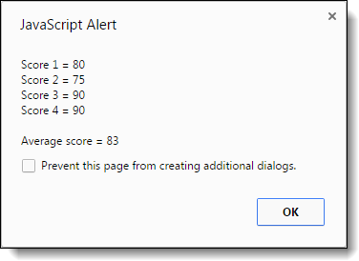

1. Open this file:

scores.html

1. Run the application, and note that it writes the results in the browser page. Then, review the JavaScript code.
2. Modify the application so it provides for a fourth test score.
3. Modify the application so it displays the results in a dialog box like the one above, as well as in the browser page after the dialog box is closed.